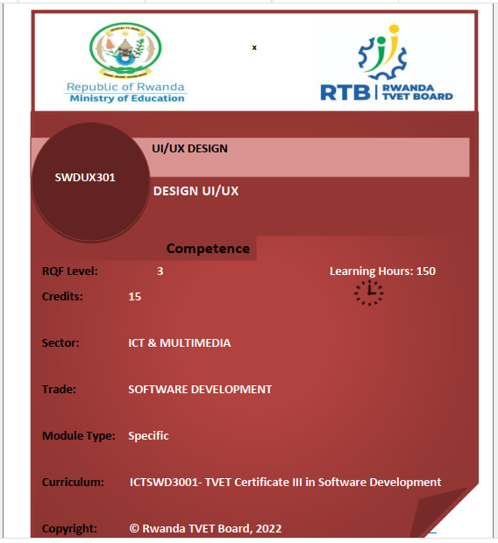

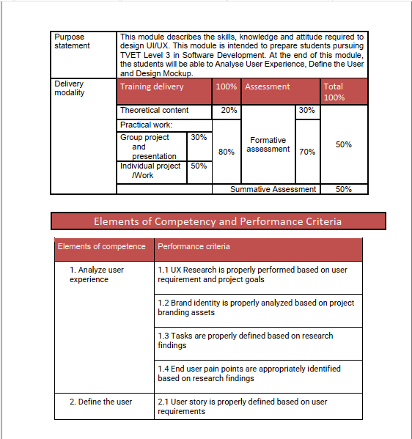

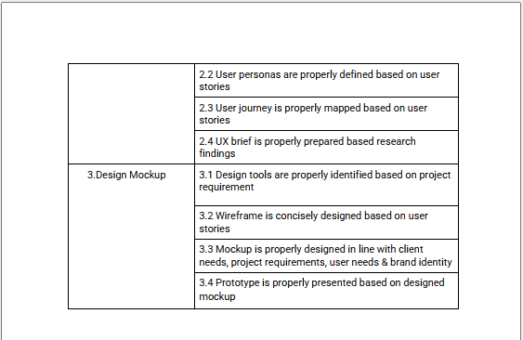

**Purpose statement:** *This module describes the skills, knowledge and attitude required to design UI/UX. This module is intended to prepare students pursuing TVET Level 3 in Software Development. At the end of this module, the students will be able to Analyse User Experience, Define the User and Design Mockup.*

**Learning outcome 1: Analyse User Experience**

**Indicative content 1.1:** Definition of key concepts

**User experience:** (UX) refers to the user’s journey when interacting with a product or service. UX design is the process of creating products or services that provide meaningful experiences for users, involving many different areas of product development including branding, usability, function, and design.

**User:** Is a person who uses or operates something

**Experience:** Experience refers to conscious events in general, more specifically to

perceptions, or to the practical knowledge and familiarity that is produced by these conscious processes.

**What is user interface (UI)?**

**The user interface (UI):** is the point of human-computer interaction and

communication in a device. This can include display screens, keyboards, a mouse and the appearance of a desktop. It is also the way through which a user interacts with an application or a website.

**Interface:** point where two systems, subjects, organizations, etc. meet and interact

**Types of user interfaces**

The various types of user interfaces include:

1. Graphical user interface (GUI)

2. Command line interface (CLI)

3. Menu-driven user interface

4. Touch user interface

5. Voice user interface (VUI)

6. Form-based user interface

7. Natural language user interface

**Examples of user interfaces**

Some examples of user interfaces include:

1) computer mouse

2) remote control

3) virtual reality

4) ATMs

As conclusion

**User interface (UI) and User Experience (UX)**

At the most basic level, the user interface (UI) is the series of screens, pages, and visual elements like buttons and icons that enable a person to interact with a product or service. The goal of user interface design is to make the user's interaction as simple and efficient as possible, in terms of accomplishing user goals (user centered design).

User experience (UX), on the other hand, is the value that the end user gets while using your product. It all depends on enhancing customer satisfaction by improving the usability, accessibility, and pleasure when a user interacts with your product

**✓ User Experience research or UX research**

Is defined as users’ systematic study to discover behaviors, needs, motivations, and trends by observations, analysis, and other user feedback. UX researchers use different methods to understand problems and draw opportunities to stand out among their competition.

**✓ Research findings**

**Findings:** Are facts and phrases, observations, and experimental data resulting from research. Findings are basically the key outcome of the investigation. It is basically a key fact which you can discover during an investigation.

Research findings are facts and phrases, observations, and experimentaldata resulting from research. It’s important to note here that “finding” doesnot always mean “factual information” because conductive research relies onresults and implications rather than measurable facts.

**What is the difference between findings and research findings?**

**Findings** are basically the key outcome of the investigation. It is basically akey fact which you can discover during an investigation.

**Research findings** are facts and phrases, observations, and experimental data resulting from research.

**Steps of UI/UX Design Process**

The UI/UX Design Process are methodologies that, if followed, allows you topolish your user interfaces to be the best one possible for your business. If thisprocess is not followed, then it may end up in a situation where you need tokeep redesigning ourselves every time!

The entire UI/UX design process can be divided into 5 phase

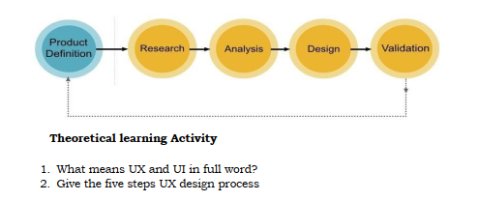

**Indicative content 1.2:** Description of UX Research

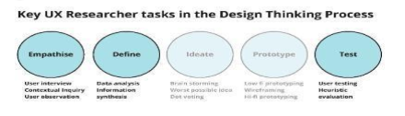or

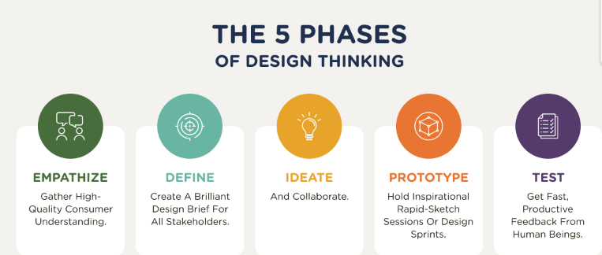

**The 5 Stages in the Design Thinking Process**

* Stage 1: Empathize—Research Your Users' Needs.(user interview, user observation, contextual inquiry)
* Stage 2: Define—State Your Users' Needs and Problems.(data analysis, information, synthesis)
* Stage 3: Ideate—Challenge Assumptions and Create Ideas.

(brainstorming, worst possible idea)

* Stage 4: Prototype—Start to Create Solutions.(low-fidelity prototyping, wireframe, hi-fidelity prototyping)
* Stage 5: Test—Try Your Solutions Out.(user testing, evaluation)

**✓ UX Research Methods and Approaches**

**Qualitative UX Research Method**

1. User Interviews

2. Diary Studies: A diary study (sometimes called a camera study) is a UX research method in which participants keep a log of their thoughts, experiences, and activities over a defined period of time, usually a few days to several weeks.

**Quantitative UX Research Methods**

1. User Surveys: “A process of asking questions that are answered by a sample of a defined group of people to get numbers that you can use to make decisions.”

2. Click Tracking: is when user click behavior or user navigational behavior is collected in order to derive insights and fingerprint users.

3. Testing: A diary study (sometimes called a camera study) is a UX research method in which participants keep a log of their thoughts, experiences, and activities over a defined period of time, usually a few days to several weeks.

**Mixed UX Research Methods**

1. Heuristic Evaluation: : (of a method of teaching) allowing students to learn by discovering things themselves and learning from their own experiences rather than by telling them things

2. Card Sorting: is a research technique that helps you discover how people understand and categorize information, and ensures you create an information architecture that matches users' expectations.

3. Usability Testing: is a method of testing the functionality of a website, app, or other digital product by observing real users as they attempt to complete tasks on it.

**✓ Benefits of UX Research**

The benefits of UX research: Better products Involving your potential customers directly helps you gain a lot of knowledge on what the customers prefer, what their pain points are, and what will help the overall improvement of the product.

UX researcher role and responsibilities The role of a UX researcher is to uncover user behaviors, needs and motivations to make products, services and websites more natural and enjoyable for users. Using qualitative and quantitative methods, they conduct comprehensive research and share the insights from research with the UX designers.

**✓ Types of UX Data**

There are two main:1.Qualitative Method2. Quantitative Method

UX research includes two main types: quantitative (statistical data) and qualitative (insights that can be observed but not computed), done through observation techniques, task analysis, and other feedback methodologies. The UX research methods used depend on the type of site, system, or app being developed.

**What are UX methods?**

**✓ Steps of UX Analysis**

1. Identification of user issues

2. Organization of UX data

3. Looking for recurring issues

4. Prioritization of fixes

5. Sharing of findings and recommendations

6. Building and testing new features

A UX competitive analysis can help you discover:

1. What user experiences are standard in your market

2. Actionable insights for improving changes

3. Opportunities to innovate within your own website’s user experience

4. What you’re doing right (and what to avoid) in your UX design

***Assessment 2. Theoretical learning Activity***

*3. Base on your understanding what are the benefits UX research*

*4. Describe the types of UX Research Methods*

**Indicative content 1.3: Analysis of Brand Identity**

**✓ Definition**

The process of Brand Identity starts with understanding and indepth analysis of the brand, the nature of the business, short-term and long-term goals, product and services offered, how does the business wants to portray (represent, describe) itself in the market, values, and fundamentals that have formulated the business.

A brand is a name, term, design, symbol or any other feature that distinguishes one seller's good or service from those of other sellers.

A **brand** is the unique identity and perception of a company, product, or individual in the eyes of the public. It's more than just a logo or a name—it's the overall experience and reputation that people associate with a business or offering.

**Key Elements of a Brand:**

1. **Name**: The brand’s name is often the first thing people notice and serves as a primary identifier.
2. **Logo**: A visual symbol that represents the brand, often serving as the most recognizable feature.
3. **Tagline**: A memorable phrase or slogan that conveys the essence or promise of the brand.
4. **Design Elements**: This includes colors, fonts, and other visual components used consistently across marketing and products.
5. **Voice & Tone**: How the brand communicates with its audience, whether it's formal, casual, friendly, authoritative, etc.
6. **Values & Mission**: The guiding principles and purpose behind the brand that influence how it operates and interacts with customers.
7. **Customer Experience**: The feelings and perceptions that customers have when interacting with the brand—this can be through customer service, product use, advertising, or social media.
8. **Reputation**: The collective opinions and attitudes people have about the brand based on their experiences and the brand’s actions.

**Brand vs. Branding:**

* **Brand**: The overall perception and identity (what people think about you).
* **Branding**: The process of creating and shaping that identity through design, messaging, and consistent communication.

**Brand Identity:** The brand identity is the unique set of brand associations that represent what a brand stands for and promises to its customers. Or Brand identity is the visible elements of a brand, such as color, design, and logo, that identify and distinguish the brand in consumers' minds.

**✓ Principles of branding design:**

**Design is brand.**

**1. Consistency**: The design elements (logo, color palette, fonts, imagery) must be consistent across all brand touchpoints (website, packaging, social media, advertising).

**2. Simplicity**: A simple, clear design is easier for people to remember and recognize. It also ensures that the brand message is conveyed without overwhelming the audience.

**3. Memorability**: Branding should be distinctive and unique to make a lasting impression on the audience. This could be achieved through a standout logo, tagline, or design style.

**4. Relevance**: The brand’s design should resonate with its target audience and reflect the brand’s values, culture, and positioning in the market.

**5. Flexibility**: While maintaining consistency, the brand design should also be flexible enough to adapt to different uses (digital, print, social media) without losing its essence.

**6. Timelessness**: A well-designed brand avoids following short-lived trends. Instead, it should aim to remain relevant and impactful over time.

**7. Emotional Appeal**: A good brand design should connect emotionally with its audience. This is often achieved through the right combination of visuals, colors, and messaging.

**8. Storytelling**: The brand’s design should tell a story about who the brand is, what it stands for, and how it serves its customers.

**9. Scalability**: The brand's design should be scalable, meaning it works well in any size—from a large billboard to a small business card or icon.

**10. Authenticity**: The brand should remain true to its core values and mission. Authenticity in design ensures that the brand’s message and visuals align with its actions.

**alternative**

**Integration.**

Even though they emerged as two different disciplines, design and branding need to be integrated if you want them to be effective. A product cannot do without its brand image, and brand image is nothing without design.

**Understanding the brand.**

The more you know, the better you are as an expert. This is true when it comes to the design process. If a designer does not understand your company’s core values, your deepest origins and the mission of your product or service, the design process and the end-product might fall short of a great story behind it.

**Relationships.**

People respond to emotion. If they cannot connect with a brand or make arelationship happen, you know it will not work for either side. It is a designer’sresponsibility to make an emotion-evoking design, similarly to what Apple has done with their products with which their users feel a deep connection. iPhones, and that is something that would not work without a good branding design.

**Strategy.**

What many startups and small companies do not realize is that they need to employ a branding strategy early on, from the very founding of the company.

**Innovative solutions.**

In a world where almost every product and every service are the same as another, it is hard not to have similar ideas and use the same concepts for certain work. The designers, however, need to be there to make things different from one another and offer innovative design solutions that will leave their competition behind.

**Reinvention.**

Many companies today use their branding options to reinvent the brand and yetretain the same image in the eyes of their audience.

**Do not overdesign.**

When one starts the creative process, it is very difficult not to get carried away and do more than required, even to the point of ruining the entire concept.

**Making a difference.**

Many people forget about this important thing, but this principle relies on beingdifferent than everyone else. No matter if you work on the local or global market,you have got to have what it takes to step out and say:

✓ **Identification of Brand Competition**

Brand Competition can be defined as the conflict between the companies offeringthe similar line of products or services in the same target market and to the sametarget audience with the goal to have the higher market share, increasedrevenues, huge profits, and growth as compared to the contemporary brand at the marketplace. Knowing and astutely understanding the competitors of your brand is one of the crucial steps to plan and execute a successful business strategy.

**Types of Brand Competition:**

### 1. **Direct Competition:** Brands that offer similar products or services targeting the same customer base.

* **Example**: Coca-Cola vs. Pepsi.

### **2. Indirect Competition:** Brands that provide different products or services but fulfill the same customer need.

* **Example**: Coffee shops vs. tea shops

**3) Replacement Competition:** Replacement competition is the tricky(deceive)situation when your customer indulges in the purchase of other product insteadof choosing your product to which he has been committed for a longer period oftime.

**Example**: A bicycle vs. a car for transportation.

**✓ Identification of Brand Personas**

Personas are fictional(imagined) characters, which you create based upon your

research in order to represent the different user types that might use your service, product, site, or brand in a similar way. Personas help designers to create understanding and empathy with the end users.

User personas help designers shape product strategy and accompany during the

usability testing sessions.

**Personas** are fictional characters created to represent different user groups or target audiences. They are based on real-world research and data, and are used to inform design decisions, marketing strategies, and product development.

**Personas** are fictional characters created to represent different user groups or target audiences. They are based on real-world research and data, and are used to inform design decisions, marketing strategies, and product development.

**Key characteristics of personas:**

* **Demographics:** Age, gender, occupation, education, income, etc.
* **Goals:** What they want to achieve or accomplish.
* **Motivations:** What drives their behavior and decisions.
* **Frustrations:** What challenges or obstacles they face.
* **Needs:** What they require to achieve their goals.

**Benefits of using personas:**

* **Empathy:** Helps designers and marketers understand users on a deeper level.
* **Focus:** Keeps the team focused on the needs of real people.
* **Prioritization:** Helps prioritize features and functionalities based on user needs.
* **Communication:** Provides a common language for discussing users and their needs.

By creating and using personas, teams can develop products and services that better meet the needs and expectations of their target audience.

**Theoretical learning Activity** Theoretical learning Activity

Q1. Explain three types of Brand Competition based on brand competition

Q2. Name any four principals of brand design

**Practical learning Activity**

Using your computer with the internet download different image that will help to Make brand.

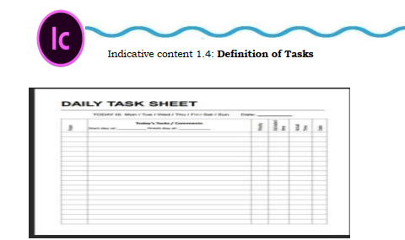

Task analysis is a process that helps UX designers learn how users actually go aboutcompleting tasks with a product.

A user experience (UX) designer is responsible for improving user interaction with a product, whether a website or application, by helping users achieve their goals quickly and smoothly. UX designers use task analysis when developing their product to gain insight and receive feedback from users. Learning more about this process can help you understand its methodologies and function in product development.

**steps**

1. Understand product specifications and user psychology

2. Interpret data and qualitative feedback

3. Create user stories, personas, and storyboards

4. Define the right interaction model and evaluate its success

5. Develop wireframes and prototypes around customer needs

6. Find creative ways to solve UX problems (e.g. usability, findability)

7. Work with UI designers to implement attractive designs

8. Communicate design ideas and prototypes to developers

**Indicative content 1.5: Identification of end user pain point**

**✓ Identification of end user pain point**

**Pain points:** are problems that occur at the different levels of the customer experience: interaction level, customer-journey level, or relationship level.

**Three Levels of Pain Points**

1. **Interaction-level pain point:**

refer to challenges or frustrations that customers experience during their interactions with a product, service, or brand. These pain points can significantly impact the overall customer experience and can arise at various touchpoints throughout the customer journey.

A user is passed from support person to support person. We’ve all been there — we call customer support, say what we need, only to be passed to another department who “will be able to handle that request.

### Key Characteristics of Interaction-Level Pain Points:

1. **User Experience (UX) Issues**:
   * Difficulties navigating a website or application.
   * Confusing layouts or poorly designed interfaces that hinder usability.
   * Slow loading times or system glitches during use.
2. **Customer Support Challenges**:
   * Long wait times for assistance or unhelpful responses from support staff.
   * Lack of clear communication channels, making it hard for customers to get help.
   * Inconsistencies in information provided by different support representatives.
   1. Journey-level pain point: A user places an order and does not receive it for months.

**Journey-level pain points** refer to challenges or frustrations that customers experience throughout their entire customer journey with a brand. These pain points can occur at various stages, from awareness to post-purchase, and can significantly impact overall satisfaction and loyalty.

### Key Characteristics of Journey-Level Pain Points:

1. **Awareness Stage Challenges**:
   * Difficulty finding information about the brand or products.
   * Misleading advertising or unclear messaging that leads to confusion.
2. **Consideration Stage Frustrations**:
   * Lack of sufficient product information or comparisons to make informed decisions.
   * Complicated navigation on websites, making it hard to browse options.

3. Relationship-level pain point: A user pays for a service but still has to watch ads.

**Relationship-level pain points** refer to challenges or frustrations that arise in the ongoing relationship between a customer and a brand. These pain points typically involve emotional or psychological aspects of the customer experience and can significantly impact customer loyalty, trust, and satisfaction.

### Key Characteristics of Relationship-Level Pain Points:

1. **Trust Issues**:
   * Concerns about data privacy and security may lead to hesitation in engaging with the brand.
   * Past negative experiences that erode confidence in the brand’s reliability.
2. **Communication Gaps**:
   * Lack of personalized communication can make customers feel undervalued or ignored.
   * Inconsistent messaging or branding that confuses customers about the brand’s identity.

**The Effects of Pain Points on Users**

### 1. Pain Points Incur a Cost to Users

* **Definition**: Users may face various inconveniences or frustrations when interacting with a product or service. These pain points can lead to additional costs, whether in terms of effort, or resources.
* **Examples**:
  + **Increased Effort**: Users may have to exert more energy to navigate a complicated interface or process.
  + **Frustration and Stress**: Ongoing issues can lead to emotional distress, affecting overall satisfaction and well-being.

### 2. Pain Points Will Incur a Time Cost

* **Definition**: Many pain points result in users spending more time than necessary to achieve their goals, whether that’s completing a task, finding information, or resolving an issue.
* **Examples**:
  + **Longer Processes**: A cumbersome checkout process can lead to longer wait times and frustration.
  + **Inefficient Support**: Users may spend excessive time trying to get help from customer service, especially if they encounter long wait times or unhelpful responses.

### 3. Financial Cost to the User

* **Definition**: Pain points can also lead to direct financial costs for users, either through increased expenditures or lost opportunities.
* **Examples**:
  + **Lost Revenue**: For businesses, pain points that affect efficiency can lead to lost sales, which ultimately impact users who may miss out on timely services or products.

**Formative assessment**

Theoretical learning Activity

Q1. According to the bellow statement answer True or False

a. Three Levels of Pain Points are plan, observation and Relationship.

b. Pain points are problems that occur at the different levels of the customer experience.

Q2. Discuss about effects of Pain Points on Users.

Attempt all questions

Q3.Cycle the letter corresponding to the best answer:

1) UX is:

A. User xampp

B. User unknown

C. User experience

2) UI is:/

A. User Internet

B. User Intermediate

C. User Interface

**3) Which one will be Types of user interfaces/2marks**

A.GUI

B.CSS

C.HTTP

**4) Choose the correct answer**

Steps of UI/UX Design Process are

a) Product definition, Design

b) Design, Research, Product definition

c) Product definition, Research, Analysis, Design, Validation.

**5) Answer True or False**

a. user interface (UI): is also the way through which a user interacts with

an application or a website.

A good UX analysis report should:

* Highlight the most urgent issues
* Be specific about the nature of each issue
* Include evidence like videos, screenshots, and transcripts
* Recommend solutions that are effective and efficient
* Include positive findings to let your team know what’s working well

**Learning outcome 2: Define the user**

**Indicative content 2.1:** **Definition of key terms**

**✓ User story:** **is a** short, simple description of a feature told from the perspective of the person who desires the new capability, usually a user or customer of the system.

**✓ User personas** User personas, also known as customer personas or buyer personas, are fictional representations of ideal customers or users that businesses create to better understand their target audience. These personas are typically based on market research, data, and demographic information to create a detailed and relatable profile of different customer segments. User personas help businesses and product development teams tailor their products, services, marketing strategies, and user experiences to better meet the needs and preferences of their target customers.

**Creating user personas involves gathering information about the following aspects:**

**Demographics:** This includes age, gender, location, income level, education, and other relevant personal information.

**Psychographics:** Understanding the values, attitudes, beliefs, and lifestyles of your target audience. What are their interests, hobbies, and behaviors?

**Pain Points and Goals:** Identifying the challenges or problems that your personas face and their goals or aspirations related to your product or service.

**Buying Behavior:** Understanding how your personas make purchasing decisions, where they research products, and what factors influence their choices.

**Communication Preferences:** Determine the preferred communication channels and methods for reaching your personas, whether it's email, social media, phone calls, or in-person interactions.

**User Journey:** Mapping out the typical path that each persona takes when interacting with your brand or product. This includes awareness, consideration, purchase, and post-purchase stages.

**✓ User journey:** A user journey is a path a user may take to reach their goal when using a particular website. User journeys are used in designing websites to identify the different ways to enable the user to achieve their goal as quickly and easily as possible.  
**✓ UX brief (UX project brief):** a UX design brief is a concise**(***giving a lot of information clearly and in a few words*) document that aims(*a result that your plans* ) at describing your design project.

**Indicative content 2.2**: **Creation of user story**

**✓ Characteristics of user story**

* Be complete enough to demonstrate user value.
* Be short, simple, and clear.
* Contain supporting files and documentation if necessary.
* Be comprehensive enough to demonstrate value, but simple enough to develop in a single iteration.
* Be written based on the input of all stakeholders.
* Be flexible and negotiable without impacting other stories or features.
* Be easy to test.
* Include acceptance criteria (conditions of satisfaction) for testers.

**✓ Benefits of user stories**

Why write user stories in the first place? Because they offer numerous benefits for an Agile project. Here are a few examples:

* **Simplified format:**User stories are written in easy-to-understand language. This eliminates confusion and makes it easier to grasp what the customer is looking for.
* **Increased flexibility:**Because user stories don’t go into technical detail, they can be molded to fit changing situations.
* **Improved collaboration:**When team members are aligned on one goal, they can work better together and collaborate easily with other project [stakeholders](https://www.wrike.com/project-management-guide/faq/what-is-a-stakeholder-in-project-management/).

**✓ Create user story**

### Five steps for writing user stories

Want some practical advice on how to write user stories?

Use these five steps as a guide:

##### **Step 1: Outline acceptance criteria**

Define the specific acceptance criteria for each user story and use it as a checklist.

##### **Step 2: Decide on user personas**

Conduct extensive (*covering or affecting a large area*)user research by creating surveys, hosting focus groups, and reading user forums. Analyze your data and search for patterns(*drawing*) to identify your key [personas](https://www.wrike.com/blog/how-create-marketing-persona/amp/).

##### **Step 3: Create tasks**

Break your user story down into numerous [tasks](https://www.wrike.com/agile-guide/epics-stories-tasks/) to make it more manageable. If it is a complex requirement, you can also add subtasks. Include detailed descriptions, so your team is aligned on what each task requires.

##### **Step 4: Map stories**

Use [story mapping](https://www.wrike.com/blog/story-mapping-tools-guide/) to structure work in a large process. In this case, your user stories will take the form of ordered steps.

##### **Step 5: Request feedback**

Speak to users and potential customers to find out what they want. Ask them for their opinions on existing products or if they have suggestions for new features. Incorporate this feedback into your user story.

**Indicative content 2.3:Identification of user personas**

**✓ Importance of user personas**

User personas help a product team find the answer to one of their most important questions, “Who are we designing for?” By understanding the expectations, concerns, and motivations of target users, it’s possible to design a product that will satisfy users’ needs and therefore be successful.

**✓ Characteristics of user personas**

1 Personas aren’t fictional guesses at what a target user thinks

2 Personas reflect real user patterns, not different user roles.

3 A persona focuses on the current state (how users interact with a product), not the future (how users will interact with a product).

**✓ User personas in design process**

* Understand (Empathize, Define)
* Explore (Ideate, Prototype)
* Materialize (Test, Implement)

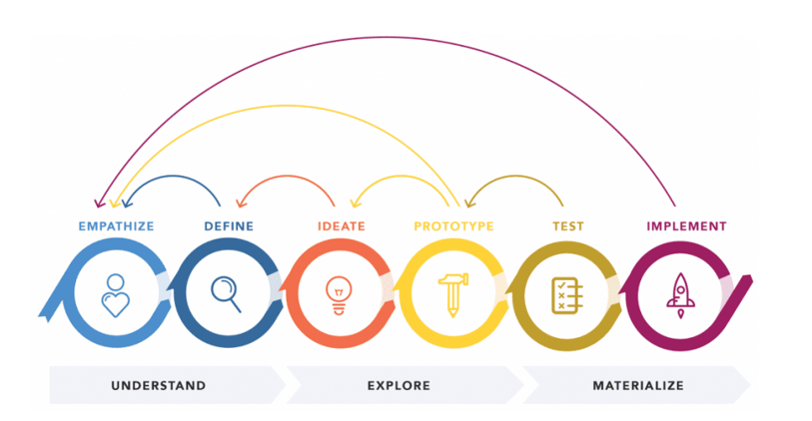

**✓ Steps of creating user personas**

### 1. Collect the information about your users

### 2. Identify behavioral patterns from research data

### 3. Create personas and prioritize them

### 4. Find scenario(s) of interaction and create user personas UX documentation.

### 5. Share your findings and obtain acceptance from the team

**Indicative content 2.4:** **Creation of user journey**

**✓ Types of user journey map**

* UX journey map
* Sales journey map
* Customer experience journey map

A user journey map gives a visual representation of a customer’s experience. This visualization might cover a customer’s entire relationship with a brand or focus on a select experience they might have while interacting with an app or website.

A user journey map details how your users move through marketing and sales funnels to get a better picture of how they interact with your company and brand.

* **UX journey map:** are the simplest type of user journey maps. They’re all about tracking behaviors at each phase of a process from beginning to end. Experience maps are used to visualize the steps someone takes to achieve a desired goal, like buying a car or ordering take-out through a delivery app.
* **Sales journey map:** A customer journey map is **a diagram (or several diagrams) that depict the stages customers go through when interacting with a company**, from buying products online to accessing customer service on the phone to airing grievances(problems) on social media.
* **Customer experience journey map:** A customer journey map is **a visual storyline of every engagement a customer has with a service, brand, or product**. The creation of a journey map puts the organization directly in the mind of the consumer, so they can see and understand their customer's processes, needs, and perceptions.
* **Service blueprints**  
  Service blueprints detail the individual actions performed by everyone involved in the delivery process—including the customer. By focusing on touch points across channels and departments. They focus on the customer as well as the roles employees and service providers play in different scenarios.
* **There are four major elements to service blueprints:**  
  1. **Customer actions.** What customers do when engaging with a service provider  
  2. **Front stage actions.** Employee actions that the customer sees  
  3. **Back stage actions.** Everything that occurs on the backend, out of the customer’s view.  
  4. **Processes.** All of the events and inner workings of the organization that make the business work.

✓ Elements of a user journey map

* Persona
* Scenario
* Stages of the journey
* User actions
* User emotions and thoughts
* Opportunities
* Internal ownership

**Indicative content 2.5:** Perform UX Research

✔ **8 Tips for Creating and Using a User Journey**

**Before Creating a User Journey**

**1. A User Journey Should Have a Business Goal behind It**

Each user journey should always be created to support a known business goal.

**2. A User Journey Should Be Based on User Research**

importance of a user journey depends heavily on the quality of insights it provides. User journeys should be built from both qualitative and quantitative findings. The process of creating a user journey has to begin with getting to know users.

**When Creating a User Journey**

**3. Don’t Jump Straight to Visualization**

The temptation to create an aesthetic graphic can lead to beautiful yet flawed user journeys. It’s recommended to start with sticky notes on a wall or visualize the path with a simple spreadsheet.

**4. Don’t Make It Too Complex**

While designing user journey it’s easy to get caught up in the multiple routes a user might take. It’s recommended to start with a simple, linear journey (an ideal way to get the users to the given goal).

**5. More Ideas Lead to Better Design**

It’s essential to involve all team members in the process of creating a user journey, especially in large organizations

**Use Your User Journey**

**6. Assign Ownership**

Without ownership, no one has the responsibility or empowerment to change anything. That’s why it’s important to assign ownership for different parts of the journey map (e.g. key touchpoints) to internal departments or directly to responsible individuals

**7. Socialize Stakeholders**

Reference your user journey during meetings and conversations to promote a narrative that others believe in and begin to use on a regular basis.

**8. Maintain Journeys Over Time**

Set a time each quarter or year to evaluate how your current user experience matches your documented user journeys. Consider when you may need to update the journey (such as after a major product release when the behavior of a user may change).

**Learning outcome 3: Design Mockup**

**● Description of Key Concepts**

**✓ User interface**

In general, an interface is a device or a system that unrelated entities use to interact. According to this definition, a remote control is an interface between you and a television set, the English language is an interface between two people, and the protocol of behavior enforced in the military is the interface between people of different ranks.

### What is user interface (UI)?

The user interface (UI) is the point of human-computer interaction and communication in a device. This can include display [screens](https://www.techtarget.com/whatis/definition/screen), [keyboards](https://www.techtarget.com/whatis/definition/keyboard), a mouse and the appearance of a [desktop](https://www.techtarget.com/searchenterprisedesktop/definition/desktop). It is also the way through which a user interacts with an [application](https://www.techtarget.com/searchsoftwarequality/definition/application) or a [website](https://www.techtarget.com/whatis/definition/Web-site).

The growing dependence of many businesses on web applications and mobile applications has led many companies to pla ce increased priority on UI in an effort to improve the user's overall experience.

In the industrial design field of human–computer interaction, a user interface is the space where interactions between humans and machines occur.

**✔ User experience**

The user experience (UX or UE) is how a user interacts with and experiences a product, system or service. It includes a person's perceptions of utility, ease of use, and efficiency.

**User Experience Basics**

User experience (UX) focuses on having a deep understanding of users, what they need, what they value, their abilities, and also their limitations.

**Factors that Influence UX**

At the core of UX is ensuring that users find value in what you are providing to them. 1. **Useful:** Your content should be original and fulfill a need

2. **Usable:** Site must be easy to use

3. **Desirable**: Image, identity, brand, and other design elements are used to evoke emotion and appreciation(thanks)

4. **Findable:** Content needs to be navigable and locatable onsite and offsite

5. **Accessible:** Content needs to be accessible to people with disabilities

6. **Credible**: Users must trust and believe what you tell them

**✓ Importance of UX/UI design the software development**

* 1. **Usability**

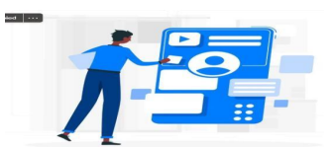

A working application is great. However, people are less likely to use (or continue to use) if it’s not user-friendly. Time spent on the UX and UI interface is designed to attract and retain users for your application.

2. Allows people to understand

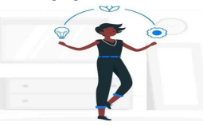

Deploying an app with a poor user experience offers a lasting look. Before deployment, you can identify and resolve problems so your first impression is good. A user-friendly app keeps people from leaving. Your software is an integral aspect of your life. Your application will be used by new users as its usability is known.

**You must consider the needs of your customers before designing the Ul UX.**

**3.Establishes your brand**

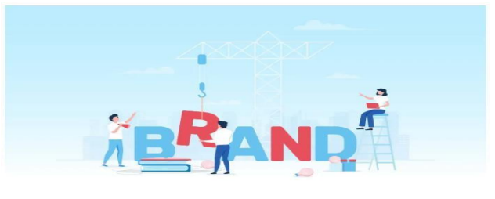

Attractive applications have more users and they’re a reality. The popular UI / UX has attracted several millions of uses, apps like Twitter, Instagram, Facebook, etc. The happiness from a great user experience makes users trustworthy.

**4.Lower costs and time management**

You have a very little risk that your clients would have an issue with your application if you invest in a great UI / UX design. A great product does not need regular updates so you save money and time on an update. The upgrade needs some money-and-time expenses. Losses for your company will occur.

The effective architecture of UX and UI saves development time. Mock-ups and prototypes smooth out problems before a long period of production. You keep track of the release date so you are less likely to go back and redo development work.

**In Conclusion**

**The role of UI/UX in the creation of apps is important.**

Most developers build a high performing device but do not concentrate on the nature that causes the device to fail. The functionality of the application is difficult to combine with UI UX design, but it is important to do that.

**Important principles of user experience design**

**1.Meet the users’ needs**

The foremost of all UX design principles is to focus on users throughout the design process. The term user experience itself makes it clear that your work needs to center on improving your users’ experience with your product or service.

**2. Know where you are in the design process**

For new UX designers who are only just testing the internship waters or are in junior positions, the design process can be overwhelming. A lot of work goes into designing, so knowing your place in the process is significant in several ways.

**3. Have a clear hierarchy**

It is easy to take hierarchy for granted, but it is a UX principle that ensures smooth navigation throughout a design. There are two chief hierarchies that you need to note.

First comes the hierarchy that is associated with how content or information is

organized throughout the design.

**4. Keep it consistent**

Users expect products to share some similarities with other products they regularly use.

This makes it easy for them to become familiar with the new product without any additional learning costs. It may sound a little counterintuitive(*describes something that does not happen in the way you would expect it to* ), but the more familiar your design is to others, the faster users can learn to use it, which enhances their experience.

**Understand accessibility**

An increasingly important rule from among the UX design basics is designing with accessibility in mind. In simple words, a designer’s responsibility is to make sure their design is usable for as many people as possible. This means that your design needs to be accessible to people with disabilities too.

**Context is key**

When designing, you need to take into account the user’s context. Location is a

commonly understood contextual factor—are you designing for someone on the go or for someone sitting at a desk? But there are other things to consider, including the time available with the user, their emotional state, the device they are using, the people who influence them, and more.

**5. Usability first**

UX design is entirely focused on solving the users’ problems, which makes usability of the design one of the most crucial user experience design principles. No matter how aesthetically pleasing your work may be, it won’t strike a chord with the user unless it is safe and easy to use.

Hence, you should conduct usability tests throughout the UX design process, including before you start your initial design, during the prototyping phases, and at the end of the process.

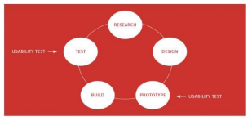

**6. Use simple language**

Just as simplicity has become a best practice in visual design, UX-focused copywriting should avoid technical terms and opt for simple language. Users are busy, they’re on the go, they’re multi-tasking, so use words in your design that are closest to the user’s thoughts.

Simple language is easy to understand, which enhances your design’s user-friendliness.

**7.Confirm before you commit**

Accidents happen all the time. Your design should help correct this, though, because you don’t want to give the user a poor experience. This makes confirmation another one of the essential UX design principles.

**8.Design with personality**

Your design can attract more users if it showcases a character that interests the user persona you are designing for. Users find it hard to connect with a lifeless design, device, or code.

Adding personality to your design gives it the human touch that makes it more attractive and usable (like the Trello blog).

**UX design process key phase**

1. Product definition One of the most important phases in UX design is actually done before the product team creates anything. Before you can build a product, you need to understand its context for existence. ...

2. Product research Once you’ve defined your idea, the product team moves to the research phase.

3. Analysis

4. Design

5. Validation (Testing)

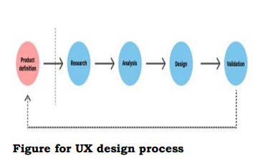

**1. Product definition**

One of the most important phases in UX design is actually done before the product team creates anything. Before you can build a product, you need to understand its context for existence. The product definition phase sets the foundation for the final product. During this phase, UX designers brainstorm around the product at the highest level (basically, the concept of the product) with stakeholders.

**This phase usually includes:**

a) Stakeholder interviews: interviewing key stakeholders to gather insights about business goals.

b) Value proposition mapping: thinking about the key aspects and value propositions of the product: what it is, who will use it, and why they will use it.

c) Concept sketching: creating an early mockup of the future product (can be low fidelity aper sketches of the product’s architecture).

**2. Product research**

Once you’ve defined your idea, the product team moves to the research phase. This phase typically includes both user research and market research. This phase can include:

Individual in-depth interviews (IDI). A great product experience starts with a good understanding of the users.

Competitive research. Research helps UX designers understand industry standards and identify opportunities for the product within its particular niche.

**3. Analysis**

The aim of the analysis phase is to draw insights from data collected during the

research phase, moving from “what” users want/think/need to “why” they

want/think/need it. During this phase, designers confirm that the team’s most

important assumptions are correct.

**This phase of the UX process usually includes:**

Creating user personas. Personas are fictional characters that represent the different user types for your product. As you design your product, you can reference these personas as realistic representations of your target audience.

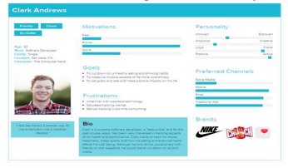

Example of a user persona, showcasing the person’s gender, age, motivations, and more. Image credit Creating user stories. A user story is a tool that helps designers understand the product/service interactions from the user’s point of view.

Storyboarding. Storyboarding is a tool that helps designers connect user personas and user stories. As the name suggests, it’s essentially a story about a user interacting with your product.

**4. Design**

When users’ wants, needs, and expectations from a product are clear, product

designers move to the design phase. At this step, product teams work on various activities, from creating information architecture (IA) to the actual UI design.

**The design phase usually includes:**

**Sketching**. Sketching is the easiest and fastest way to visualize our ideas. **Creating wireframes.** A wireframe is a tool that helps designers visualize the basic structure of a future page, including the key elements and how they fit together.

**Creating prototypes.** While wireframes are mostly about structure and visual

hierarchy (the look), prototypes are about the actual interaction experience (the look and feel).

**Creating design systems.** For large projects, designers typically create a system of components, patterns, and styles that help both designers and developers stay on the same page regarding the design.

**5. Validation (Testing)**

Validation is an essential step in the design process because it helps teams understand whether their design works for their users. The validation phase of the UX process may include the following activities:

Once the design team has iterated the product to the point where it’s usable, it’s time to test the product in-house.

**Testing sessions**. User testing sessions with people who represent your target audience are very important. There are many different formats to try, including

**moderated/unmoderated** usability testing, focus groups, beta testing.

**Surveys.** Surveys are a great tool for capturing both quantitative and qualitative information from real-world users Analytics. Quantitative data (clicks, navigation time, search queries, etc.) from an analytics tool can be very helpful to uncover how users interact with your product.

**Wireframe**

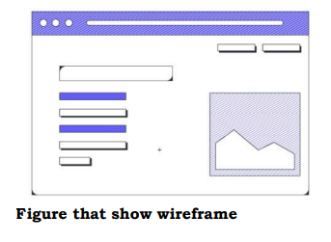

**What is a wireframe?**

A wireframe is a skeletal blueprint or framework that outlines the basic design and functions of a user interface (such as a website or application).

**The goal of a wireframe is to quickly and easily communicate:**

• The contents of the page

• The page structure and layout

• The app’s functions

In other words, a wireframe describes the basic structure, functions, and content of the page.

Wireframes can be low-fidelity or high-fidelity, depending on your needs and preferences.

A low-fidelity wireframe is often sketched out on paper or a whiteboard and is a useful way to brainstorm the basic outline for your design. A high-fidelity wireframe has more detail and may include simple workflows and interactions.

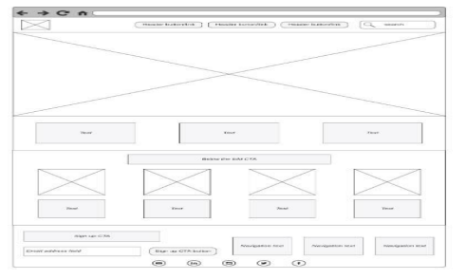

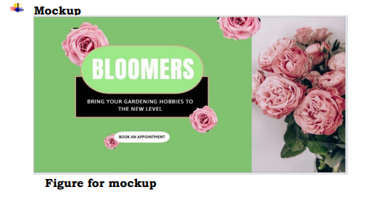

**What is a mockup?**

A mockup is the next, more in-depth iteration of the wireframe outline. A mockup is a static wireframe that includes more stylistic and visual UI details to present a realistic model of what the final page or application will look like.

A good way to think of it is that a wireframe is a blueprint(plan) and a mockup is a visual model.

**A mockup typically includes additional visual details such as:**

1. Colors, styles, graphics, and typography

2. Styled buttons and text

3. Navigation graphics

4. Component spacing

Mockups are useful tools for understanding and communicating what the final interface should look like and gives stakeholders a chance to preview design and style choices before committing to building the app in a functional prototype.

**Prototype**

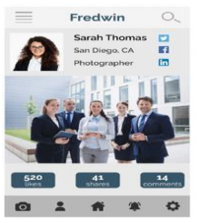

**A prototype is “**A simulation or sample version of a final product, which UX teams use for testing before launch.”

The goal of a prototype is to test and validate ideas before sharing them with

stakeholders and eventually passing the final designs to engineering teams for the development process.

Prototypes are essential for identifying and solving user pain points with participants during usability testing. Testing prototypes with end-users enables UX teams to visualize and optimize the user experience during the design process.

**Distinction from wireframe, mockup and prototype**

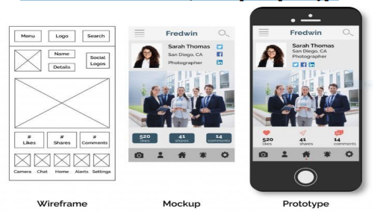**z**

***This figure shows clearly difference between wireframe, mockup and prototype .***

Distinction from wireframe, mockup and prototype

A wireframe is a quick sketch of a product intended to convey its desired functionalities.

● A mockup is a realistic design of a product designed to gather feedback on its visual elements.

● A prototype is an interactive simulation of a product designed to test the user experience.

**Information Architecture**

What is information architecture?

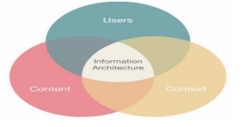

Figure that show the components of information architecture

Information architecture is a discipline that focuses on the organization of

information within digital products. For example, when designers create apps and websites, they lay out each individual screen so that the user can easily find the information they need. They also create a flow that lets users navigate between screens without much effort. UX architects determine the right organization and flow.

**Design thinking process**

**What is design thinking?**

Design thinking is a methodology that attempts to solve complex problems in a creative and user-centric way. Core features of the design thinking methodology include:

1. **Focus on end-users.** The end-user plays a key role in the design thinking

process—all key product design decisions are evaluated according to the end

user’s needs and wants.

2. **Solid problem framing.** Rather than accepting the problem as given, designers explore the problem space to find a root cause of the problem. The insights they gain can help designers reinterpret the given problem.

3. Creating tangible solutions. Convey design solutions using sketching and

prototyping as opposed to presentations and slide decks.

4. The five-stage design thinking model was originally posited by the Hasso-Plattner Institute of Design at Stanford (d.school). The design thinking stages are:

1. Empathize. Understand the problem of the user for whom you are

designing.

2. Define. Form a problem statement.

3. Ideate. Generate creative solutions to this problem.

4. Prototype. Build a tangible representation of this solution.

5. Test. Validate this solution

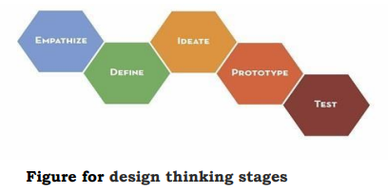

User-centered design

User-Centered Design Basics

The User-centered design (UCD) process outlines the phases throughout a design and development life-cycle all while focusing on gaining a deep understanding of who will be using the product.

The following are the general phases of the UCD process:

1. Specify the context of use: Identify the people who will use the product, what

they will use it for, and under what conditions they will use it.

2. Specify requirements: Identify any business requirements or user goals that must be met for the product to be successful.

3. Create design solutions: This part of the process may be done in stages, building from a rough concept to a complete design.

4. Evaluate designs: Evaluation - ideally through usability testing with actual users -is as integral as quality testing is to good software development.

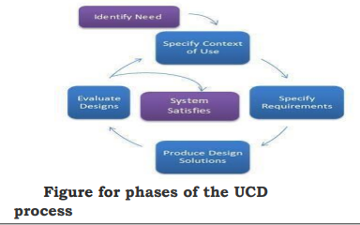

**Usability**

Usability Testing can be defined as the kind of testing performed from the end user's point of view for determining whether the application you are developing is effortlessly usable or not.

Your application may build entirely per the requirements. Still, they might not be used at the time of delivering the project in the user's hands.

Here's a simple block diagram of usability testing below:

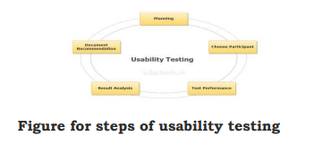

3-Clicks rule

The 3-click rule is a persistent, unofficial heuristic that says that no page should take more than 3 clicks (or taps on a touchscreen) to access. A variation pronounces that the most important information should take no more than 3 clicks to get to.

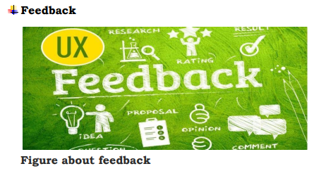

Feedback in UX: [Presenter] One of the most important mechanisms we employ in UX is feedback. Feedback is the system's response to the user's action. If you've ever submitted a form and not received a response, you've likely felt confused on whether the system worked and whether you had to do it again. Feedback gives users the confidence that their action was acknowledged by the system. Feedback is incorporated into everything we design, from how buttons behave on click to receiving an email confirmation on your new account signup.

Essentially, according to Hogue, feedback answers questions across four categories:

**Location:** Where am I?

**Current Status:** What’s happening — and is it still happening?

**Future Status:** What will happen next?

**Outcomes & Results:** What just happened?

**Indicative content 3.2: Use of Figma prototyping tool Setup Figma**

Step 1: Get access to Figma Create or sign in to your Figma account ...

Step 2: Enable the component libraries Open the design file you’d like to connect to the DDS 2 libraries.

Step 3: Manage Components are listed in the Assets panel.

Step 4: Integrate styles

Step 5: Review updates

Step 1: Get access to Figma

Create or sign in to your Figma account

If you already have a Figma account set up with your Dell or Dell team email address, visit Figma.com and sign in. If you do not have a Figma account, visit the onboarding instructions created by Dell Digital Design’s Design Operations team for instructions on how to set up your account.

You must be a member of this team before you can enable the DDS v2 component libraries.

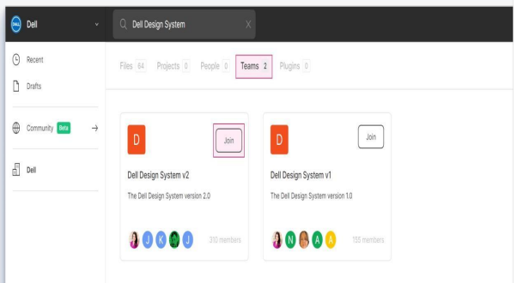

Step 2: Enable the component libraries

Open the design file you’d like to connect to the DDS 2 libraries. On the sidebar, select the Assets panel. Select the Library icon to view a list of DDS 2 libraries. To enable the libraries, use the toggle switches. While you can enable all of the libraries, the most commonly used components are located in the following two libraries:

• Components & Patterns for Web Light Mode

• Foundations & Icons Light & Dark Mode

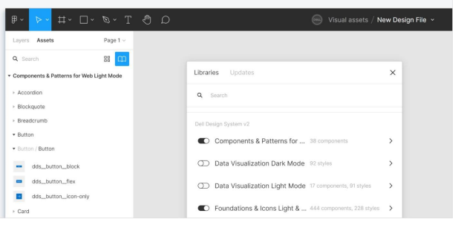

**Step 3: Manage components**

Components are listed in the Assets panel. Click any component and drag it from the panel onto your canvas. Some components are more customizable than others. Buttons, for example, contain variants and states that can be modified.

**Step 4: Integrate styles**

All of the foundational styles for colors, typography, elevation, and grid will fully integrate into Figma when you enable the DDS 2 libraries. You can access library styles in the Properties panel by selecting the style you want to update. **Step 5: Review updates**

You may see a notification that prompts you to review or dismiss component updates.

Carefully review the updates before accepting them—they may break your layout or design and you will not be able to undo those changes.

Figma interface

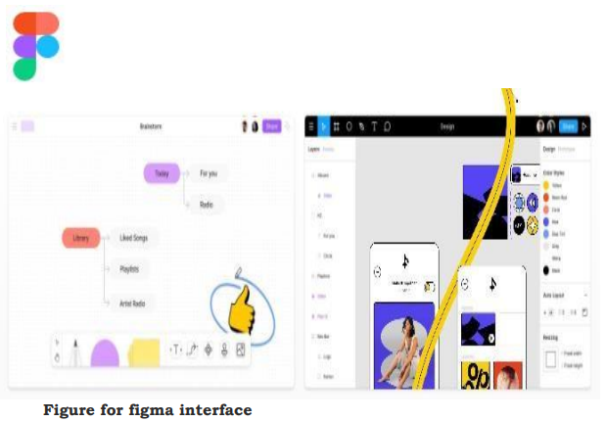

Below there are many tools we found in figma interface

1. The canvas in Figma is the backdrop on which all of your frames,

groups, and other layers live.

2. Frames allow you to access extra functionality in Figma. You will

need to use Frames to use the following features or functions: Layout

Grids.

1. Menu

2. Layers

3. Design Panel

4. Pages

5. Inspect Panel

6. Options

7. Prototype

8. Assets

**Figma Mirror**

A Full Introduction of Figma Mirror

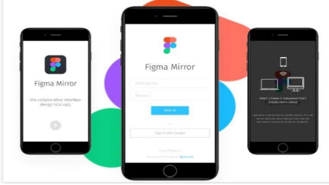

Figma mirror is the mobile version of Figma, where you can prototype your desktop designs into your mobile phones. To understand the Figma mirror, we have first to understand what Figma is? As earlier I mentioned that **Figma** is vector graphics digital designing prototype web-based software. It is generally a UI and UX designing application. Figma is proven ideal for creating a website, apps, or for small interface programs.

**Steps to Use Figma Mirror App**

Well, **Figma mirror** is a mobile version of Figma which runs for both Android and iOS. It generally helps you test your designs on mobile. It can be done by two methods first one by using the Figma mirror app, and another one is by opening the Figma mirror in the browser. If you want to know how to use Figma mirror App, then you have to follow some easy steps:

Step 1: Download the mobile version app from the play store or iOS store whichever OS you are using.

Step 2: After the downloading is done then sign in using the credentials by which you have you have logged in to your pc.

Step 3: Now select a frame from your designs, on your desktop, and it will be mirrored in your device you can also use the Figma mirror app in the browser as well to do so you have to open Figma mirror in your browser and then follow the same time steps followed above, and your design will be mirrored.

**Indicative content 3.3: Sketch wireframe**

Sketch Wireframes and Examples

**Wireframing** is the best way to design a modern and effective web-page. Traditionally, many people think of wireframing as something done with pen and paper, which left most of us non artistic people feeling left out. That's why we decided to create premade sketch wireframes for you! Create a wireframe today using one of our templates and customize it to your business objectives.

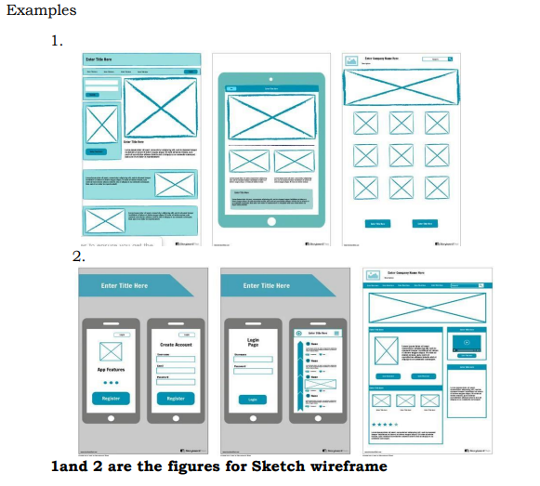

3 Tips for Creating Sketch Wireframes

**1. Skip the Color**

The point of wire framing is not to be distracted by color palettes or blinking icons, but rather to focus on the core layout and design of the page. Leave out the color and flash and focus on the order of elements and placement of your call to actions.

**2. Request Constant Feedback**

When creating a wireframe, you should always be asking for feedback from

coworkers or team members. Try to ask people from various departments, as each will offer a unique perspective on what they like about your wireframe design and where there is still room for improvement.

**3. Decide on One Clear Page Objective**

Pick one clear page goal or objective. Is the goal of this page to capture the user's email address so a sales rep can follow up? Is it to have the user start a free trial? Or is it to guide them through a self-service purchase process? Whatever it is, pick one goal and always keep that goal in mind when designing.

**Indicative content 3.4: Sketch mockup**

Setting up files

To set up the files we use the following steps:

1. Creating file

2. Create and edit frames

3. Creating pages

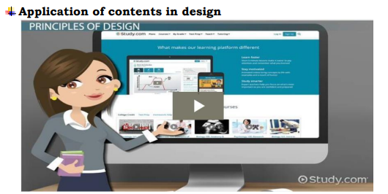

The growing interest in content design is a welcome development. Such interest recognizes that content decisions can’t be separated from the context in which the content will be used.

Content Design as Problem Solving Content design is most effective when treated as the exploration of user problems, rather than as the fulfillment of user tasks.

The following tools will help to make Application of contents in design

1. Adding predefined shapes

2. Add custom shapes

3. Pen tool Add Images

4. Masking

5. Effects and blending

6. Strokes

7. Management of layout (Auto-layout, Grid,

8. Application of element alignments

**Creation of color palettes**

Custom palettes are perfect for custom designs. Using color as a communication tool is much more intuitive than it may seem. Colors make us feel certain ways that we may find hard to explain but easy to understand

**Use Figma plugins to quickly generate a color system**

• Step 0 — Install Plugins Make sure you have these Figma Plugins installed:

• Step 1 — Create a Color Chip and Color Swatch Create a shape for your Color Chip.

• Step 2 — Duplicate and Rename Swatches Make 4 duplicates of the Color Swatch frame

• Step 3 — Add Labels with Smart Text Plugin

• Step 4 — Dial in the Colors and Create Styles

**Creation of components**

Create Your First Component. When creating a React component, the

component's name MUST start with an upper case letter.

The following elements will help to create components:

1. Reusable input components

2. Reusable checkbox and radios

3. Reusable button components

4. Content cards

**Application of mockup design**

Best Free Application Mockup PSD Templates: If you are in the process of launching your mobile product, you might need some application prototypes. It would help you please the design and then launch it on the advertisement campaigns.

**During designing mockup, we can use the following tools:**

1. Content sections

2. Navigation bar

3. Dropdown men

4. Sidebar menu

5. Design simple online shopping platform with Items listing, cart, checkout

6. Design authentication pages

7. Design a B2B platform

**Test design using Figma Mirror**

1. Run usability testing on Figma prototypes

2. Create missions for users to complete

3. A/B test designs to compare performance

4. Get quantitative data like success rates, miskick rates, and duration.

5. Review heat maps for each screen in your prototype

6. Ask follow-up questions with scales or open-ended questions

7. Find the best user flow for your designs

8. Run in-person tests using a single device

**Indicative content 3.5: Presentation of Prototype**

**✓ Starting prototyping**

How to create a prototype in 7 steps:?

If you want to learn how to create a prototype, consider following these steps:

**1. Conduct research**

When you have an idea for a product, a beneficial first step to conduct is

researching similar products. This can help you determine whether your idea is innovative

**2. Draw a design**

Before you create a prototype, it's important to design your product. A sketch can help you roughly determine what your finished product might look like and how it might function. These sketches only represent initial product ideas, so finding a design, you like is essential and may require several drafts.

**3. Develop a virtual model**

The next step toward creating an effective prototype is generating a virtual model of your product.

**4. Determine whether you require assistance**

After building a model of your product, you can now determine whether you can build the prototype yourself. If your prototype requires specific machinery to build, consider asking someone trained in using such machines to

**5. Generate a proof of concept**

A proof-of-concept prototype demonstrates how your product works. This prototype might not look exactly like your finished product, but it's important that your proof of concept contains the moving or mechanized parts from your design so you can see how each part functions together. This can help ensure you build a product that functions as intended. help you.

**6. Create your prototype**

Once you're certain you can create a functional product, you can build a version that adheres more to your model and designs. For this prototype, you can combine your visual ideas from your design with your proof of concept's functionality. With this information, you can also determine which parts of your design work and which may require adjustments.

**7. Repeat any steps as needed**

Once you test your prototype or allow your intended audience to use it, you might discover areas that require improvement. Consider returning to your sketches, 3D model or proof of concept to make any required changes. You can repeat these steps as many times as needed to find the right combination of function and design for your prototype. Then, you can show your mastered prototype to potential investors or begin manufacturing your product.

What are the benefits of using a prototype?

Creating a prototype can be an important early step toward ensuring a successful production process because it can provide you with key information about your idea for a product.

Here are some benefits of using a prototype in your product design process:

**1. Tests your product's functionality:** Testing your product can help you make adjustments to ensure optimal performance and eventual customer satisfaction.

**2. Saves money before production:** Creating one or two prototypes is typically a less expensive process than mass producing a product without testing it first.

**3. Allows you to demonstrate your product to investors** : A prototype of your product can also help you show investors what your product aims to accomplish and how well it works.

**4. Determines your product's usefulness**: Another effective method associated with creating a product is allowing select members of your intended audience to use your prototype, which can help you determine whether they believe the product is useful.

**5. Highlights the proper materials to use**: When you generate an idea for a product, you might determine the specific materials you require and an outline of your eventual product's shape. With a prototype, you can then take your original idea and learn how to create a better product at a lower cost.

**6. Helps you coherently discuss your product:** When you speak to others, such as investors, manufacturers and distributors, about your product, they might have specific questions about its dimension, weight, mobility and other aspects.

**✓Add interactivity**

Learn the basics of adding interactivity to your Adobe InDesign documents, including adding links, buttons, animation, sharing your interactive document, and more.

What types of interactivity can I add to my Documents?

There really are a lot of other types of interactivity you can add to your documents including placing video and sound files and setting options in the Media panel, working with Object States to turn multiple objects like a series of images into a multistate object that can act like a slideshow, for example, or adding working Buttons and Forms.

**✓Present Prototype**

How To Give a Prototype Presentation (and How To Be a Good Audience for One!)

Whether it’s to a client, a development team, or your fellow designers, presenting prototypes is a great skill for consultants and product designers to have. Here are some tips for helping your audience understand your prototype:

Start with the ‘why’: By reminding your audience of the context, you get everyone on the same page. Start by going over the big-picture goals, where your prototype fits into the overall project, and any specific constraints you are working within.

Tell your audience what they are about to see: Even for a really simple prototype, it’s important to verbally explain it before showing any screens.

Call out the events or steps that a user will encounter: it helps them understand what they should be looking for, and the steps they should see when you do show them your prototype.

**Make it crystal-clear:** Use arrows, color coded sticky notes or text to guide your audience through the prototype.

**Tell a story:** Storytelling helps make the product real, and helps convey the passage of time, an integration or a handoff to another part of the process. Remember that products are used by people — who is going to use yours, how will it be a part of their day, what will the user have to do, and what will be an integration?

Practice! Walk through your presentation by yourself and then also with a friend or colleague who isn’t familiar with the project.

If you’re on the receiving end of a prototype presentation, here’s how you can help make it valuable and productive:

Approach the prototype with an open mind: There are often multiple ways to interpret a solution.

Sometimes a button could work just as well as a link, or an icon — don’t let your preconceived ideas about the design of the feature or application block you from seeing other ways to solve the problem.

Don’t let the product you currently have limit the product you could have: When a prototype is intended to replace your current system, it can be tempting to feel more comfortable with the familiarity of what you already have. But remember, if your existing system was perfect, you

probably wouldn’t be trying to update it in the first place.

Be willing to give constructive feedback: If you like something, say so! And if you have concerns, speak up. Ask for time to think over a prototype if there are parts that you are unsure about and then clearly articulate why you do or don’t like it, or you do or don’t think it will work. Your perspective will only make the product stronger.

**▪ As conclusion**

Prototyping is a great design thinking tool–and the power of a prototype is enhanced when everybody can understand and react to it. A clear, engaging presentation, followed by thoughtful and open discussion, will help your final product be the best it can be.



End of module